**PANDIT DEENDAYAL ENERGY UNIVERSITY**

**SCHOOL OF TECHNOLOGY**



**DEPARTMENT OF COMPUTER SCIENCE AND ENGINEERING**

**Advanced Python Programming for Emerging Applications**

**PROJECT REPORT**

**“Traffic Analysis and Helmet Detection”**

**SUBMITTED BY:**

Mahek Rohit Gor (21BCP104)

Shruti Mishra (21BCP110)

Dhvani Patel (21BCP116)

Shivraj Nakum (21BCP125)

Heli Bhatt (21BCP438D)

**INDEX**

|  |  |  |
| --- | --- | --- |
| **Sr. No.** | **Title** | **Page no.** |
|  | Acknowledgement |  |
|  | Overview and Motivation |  |
|  | Introduction |  |
|  | Business Model Analysis |  |
|  | Project Highlights |  |
|  | Future Scope and Development |  |
|  | Learnings from project |  |
|  | Conclusion |  |

1. **Acknowledgement**

We extend our heartfelt gratitude to all those who have played a vital role in the development of the "Traffic Analysis ans Helmet Detection" This project stands as a testament to the remarkable contributions made by our dedicated team members and the invaluable support and guidance provided by our instructor and mentor, Dr. Rutvij Jhaveri.

Our project wouldn't have been successful without the dedicated and hard work of our team members: Mahek, Shruti, Heli, Dhvani, and Shivraj. Each person's unique skills and commitment were crucial in making our vision a reality, and their teamwork was the key to our project's success. Dr. Rutvij Jhaveri, as our mentor, has been a constant source of inspiration and knowledge throughout this project.

This project is a testament to the power of teamwork, mentorship, and the collective effort of all those involved. We are proud to have had the opportunity to work with such an exceptional team and mentor, and we look forward to the continued growth and impact of the " Traffic Analysis ans Helmet Detection"

Thank You

Shruti Mishra, Shivraj Nakum, Dhvani Patel, Heli Bhatt, Mahek Gor

1. **Overview and Motivation**

Overview:

The "Traffic Analysis ans Helmet Detection" is a web based solution designed to enhance road safety through the innovative use of computer vision technology. This platform harnesses the power of YOLOv5, a cutting edge computer vision model, to detect and address crucial road safety violations in CCTV footage. The violations we focus on include helmet less riders, vehicles with triple riders, and those breaking traffic signals. Our primary goal is to provide real time insights into these violations and, in turn, contribute to safer road environments.

Motivation:

The motivation behind our project stems from a compelling need to improve road safety worldwide. Road accidents and violations are a significant concern, leading to countless injuries and loss of life. As technology enthusiasts and responsible citizens, we were driven by the desire to create a solution that addresses this critical issue using advanced technology.

India witnesses a distressing number of road accidents every day, with the lack of adherence to safety measures, such as wearing helmets, being a major contributing factor. On average, India reports a staggering **1,130 accidents and 422 deaths every day**. These accidents result in injuries, disabilities, and, in the worst cases, the loss of precious lives. Each statistic represents a life disrupted or shattered, causing untold pain and suffering to families and communities.

We are inspired by the belief that every life is precious and that it is our collective responsibility to work towards safer roads. This motivation is at the heart of our project and fuels our determination to create a solution that can make a real difference in road safety, particularly in preventing accidents like the one that took our fellow student's life. Our aim is to contribute to a safer and more responsible road culture, reducing the toll of accidents in our country.

1. **Introduction**

In a world characterized by the constant evolution of technology, the pursuit of road safety remains an ongoing challenge. As we traverse the intricate web of roads and highways, the risks associated with road travel continue to haunt us. It is in this context that we introduce the " Traffic Analysis ans Helmet Detection " a comprehensive and innovative solution aimed at transforming the landscape of road safety.

India experiences a high number of road accidents every day. Many of these accidents happen because people don't use safety measures like wearing helmets. This situation has strongly motivated us to create the " Traffic Analysis ans Helmet Detection" Our main aim is not just to find violations but also to teach people about safety and prevent accidents like the one that took our fellow student's life. We want to make the roads safer for everyone.

Key Components of the Traffic Analysis ans Helmet Detection:

**1.** **YOLOv5 Based Violation Detection:**

At the core of our platform is the utilization of YOLOv5, a state-of-the-art computer vision model, for real time detection of road safety violations. These violations include:

* Helmet less Riders: Identifying riders without helmets, a critical safety breach.
* Vehicles with Triple Riders: Detecting vehicles with more riders than deemed safe.
* Vehicles Breaking Traffic Signals: Identifying vehicles that violate traffic signal regulations, posing a risk to all road users.

**2. User Friendly Interface:**

We understand the importance of simplicity and accessibility. Our platform is designed to provide an easy and intuitive user experience. Users can effortlessly upload CCTV footage videos, and our system takes care of the rest.

**3. Three-Tiered Access Levels:**

* **No Login (Free):** Users have the option to upload 30 second videos with basic accuracy. However, they are not entitled to newsletter subscriptions.
* **With Login (Free):** Registered users can upload 2-minute videos with improved accuracy and have the option to subscribe to newsletters for regular updates.
* **Premium Subscription (Rs. 100/month):** Premium subscribers can upload 5-minute videos with the highest accuracy. They also gain access to premium features, including access to datasets, newsletters, and premium content.

**4. Educational Content:**

Our commitment to road safety extends beyond detection. We provide a repository of informative blogs related to road safety and traffic rules. These resources aim to enhance user awareness and understanding of road safety issues, promoting a culture of responsible road behavior.

**5. Chatbot Integration:**

For user interaction and support, we offer a chatbot that is available to answer questions, provide assistance, and ensure a seamless experience for all users.

**6. Technical Implementation:**

The login and registration pages of our platform have been meticulously developed using a combination of technologies. The user interfaces are crafted with HTML and enhanced with the power of Tailwind CSS to provide a visually appealing and responsive design. On the server side, PHP is employed to handle user registrations and logins while ensuring the secure storage of user data in the database.

We believe that the " Traffic Analysis ans Helmet Detection " has the potential to be a game changer in road safety by harnessing the capabilities of technology to prevent accidents, educate the public, and raise awareness about responsible road behavior. As we embark on this journey, we invite you to join us in our mission to make the roads safer for all and honor the memory of those affected by road accidents. Together, we can create a brighter, safer future for road users everywhere.

1. **Business Model Analysis**

The " Traffic Analysis ans Helmet Detection " employs a multi-tiered business model that caters to the diverse needs of its users while ensuring the sustainability and growth of the project.

**1. No Login (Free):**

* + Value Proposition: Users in this category are offered a basic, no-frills service, allowing them to upload 30-second videos for road safety analysis. The primary value proposition here is accessibility, as users do not need to create accounts or pay fees.
  + Revenue Generation: This tier does not directly generate revenue through user fees. Instead, it serves as an entry point, introducing users to the platform and its capabilities.

**2. With Login (Free):**

* + Value Proposition: Registered users in this category enjoy an extended service, with the ability to upload 2-minute videos and access improved accuracy in violation detection. Additionally, they have the option to subscribe to newsletters, providing regular updates and educational content.
  + Revenue Generation: While this tier does not charge users for access, it builds engagement and user loyalty. Newsletter subscriptions may serve as a source of potential revenue through advertising and partnerships.

**3. Premium Subscription (Rs. 100/month):**

* + Value Proposition: Premium subscribers receive the most comprehensive experience. They can upload 5-minute videos, ensuring the highest accuracy in violation detection. Furthermore, they gain access to premium features, including datasets for in-depth analysis, exclusive newsletters, and premium content.
  + Revenue Generation: This tier serves as a direct revenue generator through monthly subscription fees. The premium content and datasets may attract a segment of users who are willing to pay for enhanced features and insights.

**Revenue Streams:**

* + The primary revenue stream for the " Traffic Analysis ans Helmet Detection " is the Premium Subscription tier, with users paying a monthly fee of Rs. 100 for access to advanced features and content.
  + The platform also has the potential to generate revenue through newsletter subscriptions in the "With Login (Free)" tier, particularly if it attracts a substantial user base and can offer targeted advertising or promotional content in the newsletters.

**Key Partnerships:**

* + Collaborations with road safety organizations, government agencies, and traffic authorities can provide valuable data and support for enhancing the accuracy of violation detection, as well as promoting awareness.
  + Partnerships with insurance companies and vehicle manufacturers may lead to collaborative efforts to improve road safety and potentially offer incentives to users.

**Key Activities:**

* + Developing and maintaining the platform, including the computer vision technology for violation detection.
  + Creating informative content, including blogs and newsletters, to promote awareness and education on road safety.

**Key Resources:**

* + Cutting-edge technology and infrastructure for real-time violation detection.
  + A database for storing user data and videos securely.
  + Content creation and maintenance for blogs and newsletters.

**Customer Segments:**

* + Commuters and drivers concerned about road safety.
  + Road safety enthusiasts and advocates.
  + Users seeking high-accuracy violation detection for personal or professional purposes.

In conclusion, the "Traffic Analysis ans Helmet Detection" has crafted a business model that balances accessibility and sustainability. By offering a tiered approach with both free and premium options, it caters to a broad range of users while generating revenue through subscriptions and potential partnerships. This approach not only fosters road safety awareness but also ensures the platform's long-term viability and growth.

1. **Project Highlights**

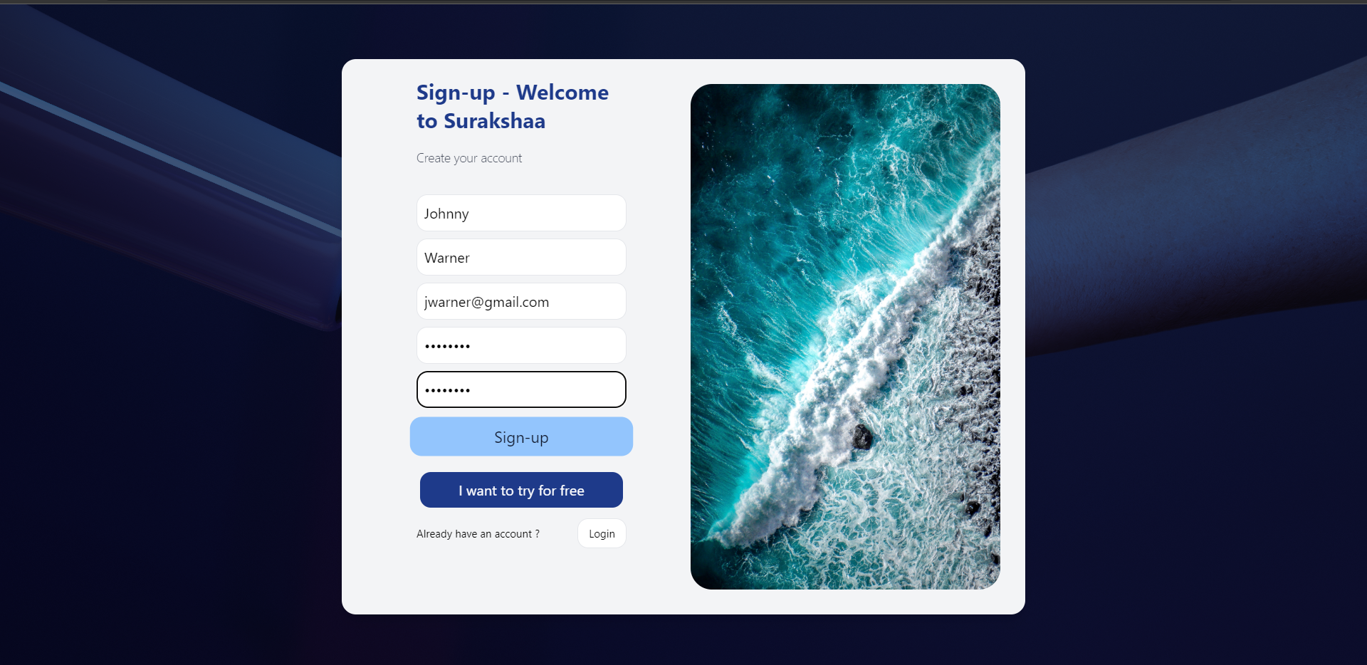

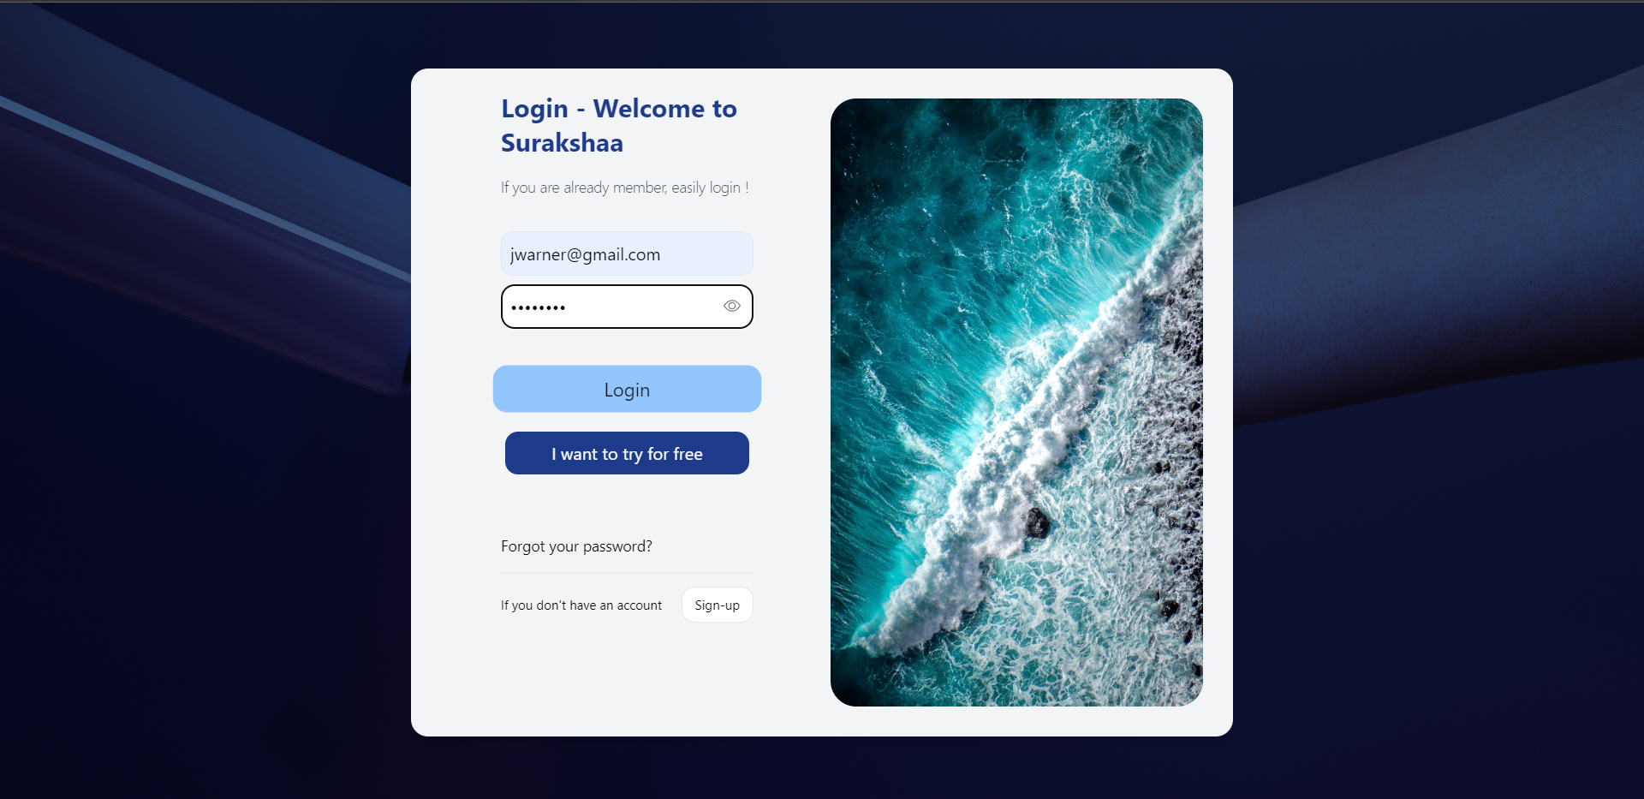

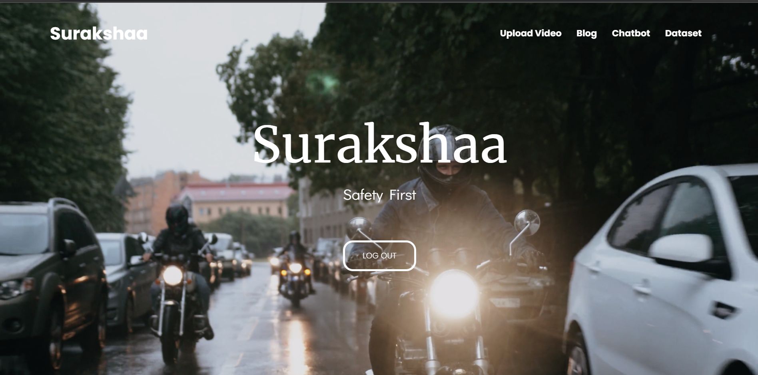

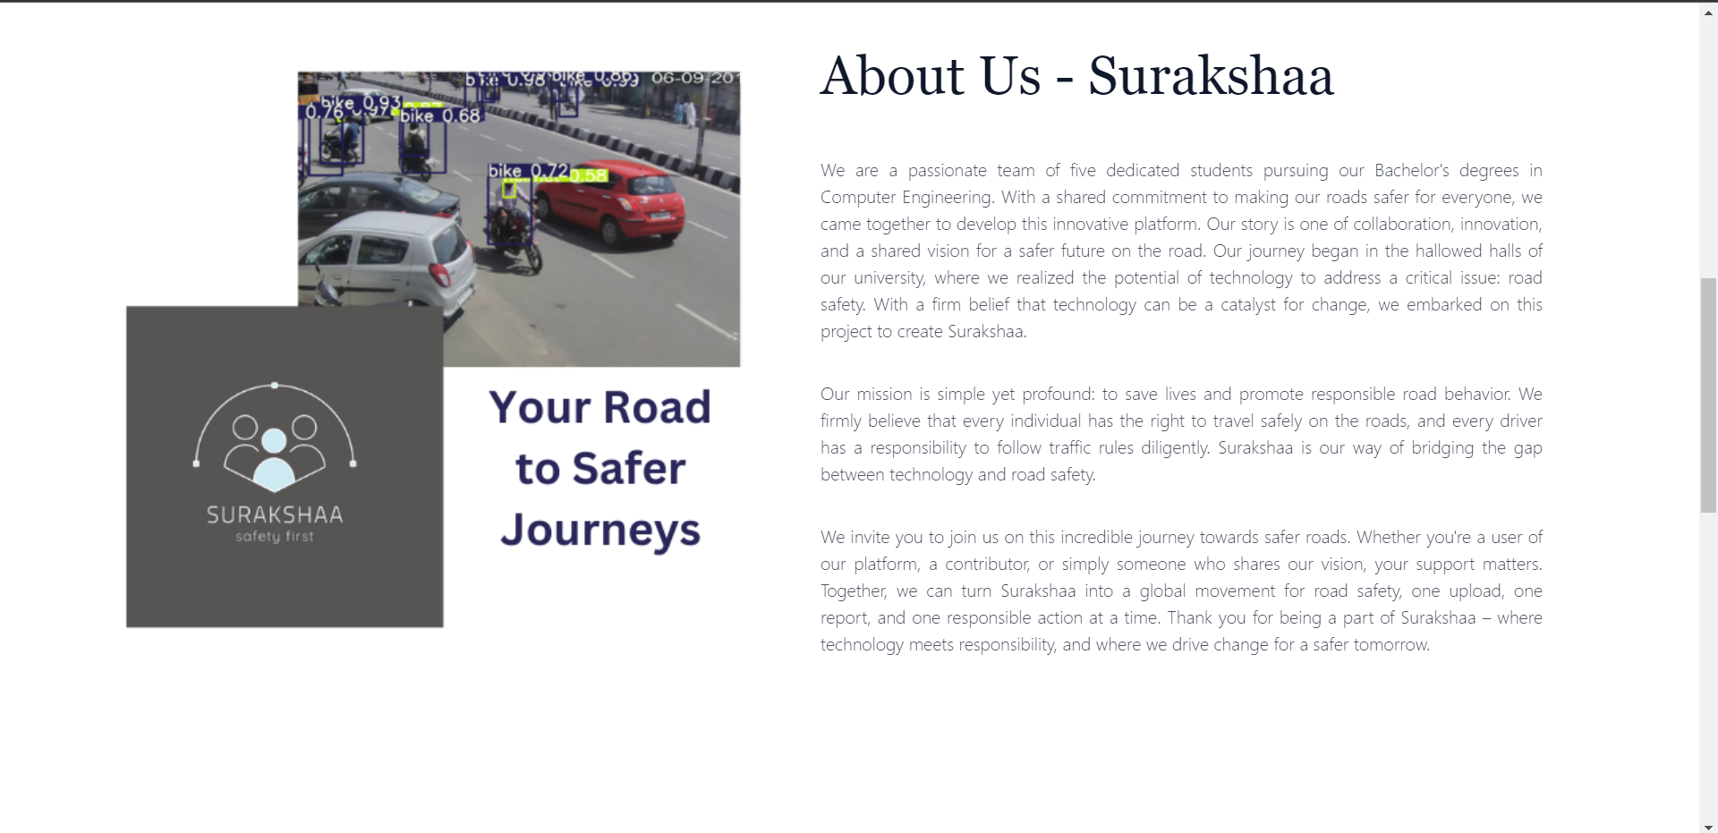

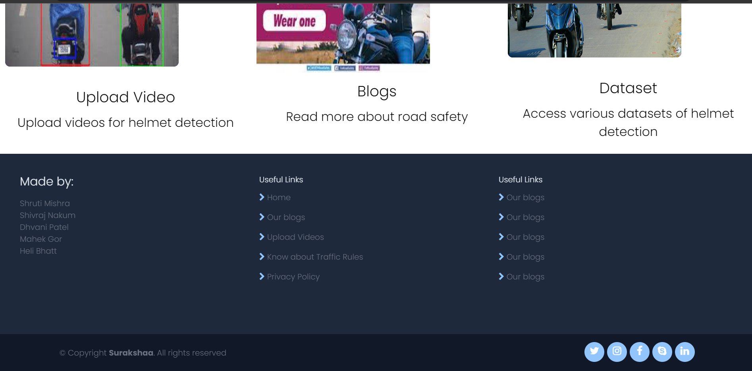

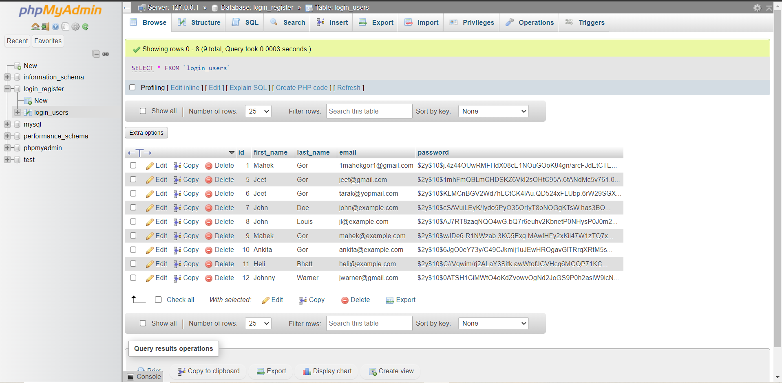

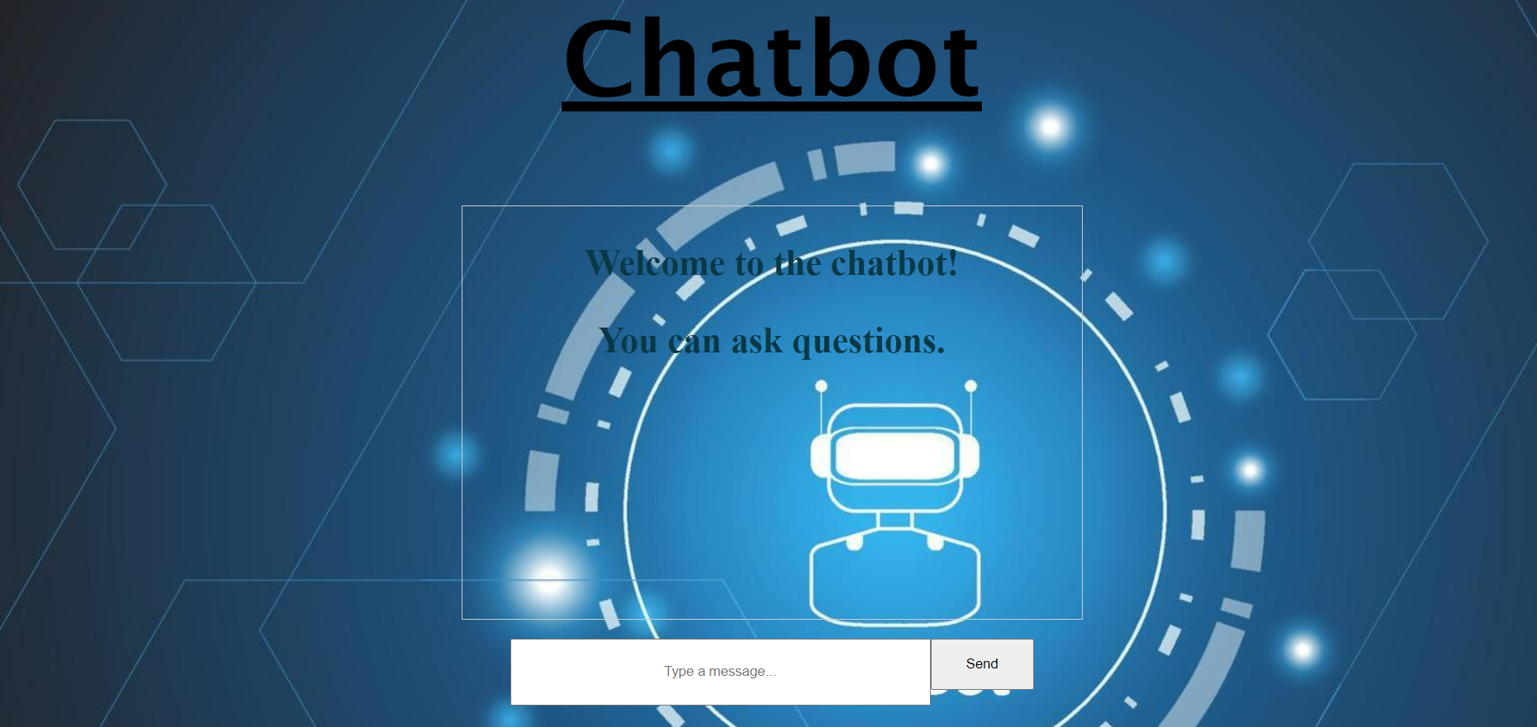

1. **Future Scope and Development**

In the coming years, the " Traffic Analysis ans Helmet Detection " holds great promise for further development and expansion. Our commitment to road safety remains steadfast, and we envision a future where our platform becomes even more robust and impactful.

One significant avenue for growth is the continuous improvement of our machine learning and artificial intelligence components. We aim to enhance the YOLOv5 model, making it even more accurate and efficient in detecting violations. Additionally, the integration of advanced machine learning algorithms will allow us to identify nuanced violations and road safety anomalies, ultimately creating a more comprehensive solution.

Furthermore, we plan to take our platform to a broader audience by developing a mobile application. This will enable users to capture and upload real-time footage directly from their smartphones, expanding the reach and accessibility of our services.

Geographic expansion is also on our horizon, as we aspire to address road safety concerns in different regions and communities. Establishing partnerships with governmental and non-governmental organizations will grant us access to real-time traffic data, fostering collaboration on road safety initiatives.

As we move forward, we will explore opportunities for data monetization, always keeping user privacy and data protection at the forefront of our priorities. Additionally, we aim to develop AI-powered driver assistance systems that offer real-time feedback to drivers, encouraging safe practices and reducing violations.

Gamification elements will incentivize safe driving behavior, and a certification system will recognize users who consistently adhere to road safety regulations. We also envision a community space where users can share experiences, discuss road safety concerns, and actively engage in the promotion of responsible road behavior.

Education and outreach are essential components of our future development, including partnerships with educational institutions to incorporate road safety awareness programs into curricula. Moreover, we plan to introduce crowdsourced road safety initiatives, allowing users to report concerns in their local areas and driving community-driven efforts to enhance safety.

By integrating with emergency response systems, we will provide immediate assistance in the event of an accident or violation, further enhancing road safety and well-being. Our ongoing research and analysis efforts will keep us at the forefront of road safety trends and innovations.

In this journey, our users, partners, and supporters are invaluable. Together, we will continue to make the roads safer for everyone, honoring the memory of those affected by road accidents and working toward a brighter, safer future on our roads.

1. **Learnings from project**

Our journey in developing the " Traffic Analysis ans Helmet Detection " has been a profound learning experience, transcending the boundaries of technology and encompassing a holistic understanding of real-world challenges. We've gathered invaluable insights that extend beyond the confines of this project, deeply impacting our educational and professional growth. Here are some of the key learnings:

**1. Integrating Advanced Technologies:**

Embracing computer vision technology, exemplified by the YOLOv5 model, has expanded our horizons. We've learned how to harness cutting-edge AI for real-world applications, not only in road safety but across various domains.

**2. Cross-disciplinary Skills:**

Our project has demanded a wide array of skills, from software development and database management to user interface design and content creation. We've realized that effective solutions often require a diverse skill set, reflecting the real-world demands of modern technology projects.

**3. Real-world Application of Course Topics:**

This project has been a direct bridge between our coursework and practical application. It covered several key topics from our syllabus, such as file handling, automation, web scraping, and visualization and analysis. We've seen how these concepts can be harnessed to solve real problems, reinforcing the relevance and significance of our academic studies.

1. **Conclusions**

In conclusion, the " Traffic Analysis ans Helmet Detection " represents the synergy of advanced technology and unwavering dedication to road safety. It has not only offered a practical solution for detecting violations but also acted as a bridge between our academic studies and real-world application. Inspired by a profound loss and the concerning statistics of road accidents in India, we remain committed to creating a safer road culture. As we move forward, we see a future filled with possibilities for further innovation, geographic expansion, and partnerships. Our project is more than a mere endeavor; it is a mission to prevent future tragedies and make the roads safer for all, inviting everyone to join us in this ongoing journey. Together, we can create a brighter, safer future on our roads.